K.R. MANGALAM UNIVERSITY

CAREER MAPPING REPORT

Name : Rashi Mangal
Roll No. : 2501730043
Course : B.Tech CSE (AI/ML)
Section : B
Course Name : Computer Science Fundamentals & Career Pathways
Course Code : ETCCCP105
Submitted To : Mr. Aryan Sharma

What Is Cloud Computing?

Cloud computing is a technology that enables on-demand access to shared computing resources—such as servers, storage, databases, networks, software, and applications—over the internet. Instead of owning and maintaining physical hardware, users can use these resources remotely through cloud service providers. Cloud computing offers flexibility, scalability, and cost efficiency by delivering IT resources as a service.

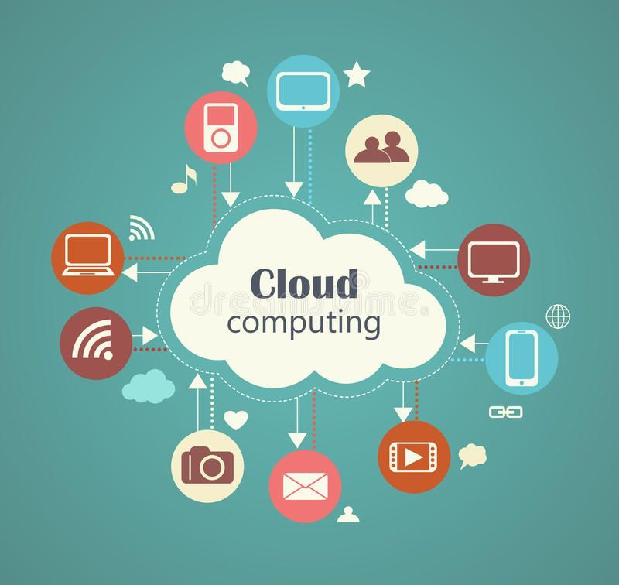

Importance And Relevance In The Current Tech Landscape
- Cost Efficiency: Reduces hardware, maintenance, and operational costs with pay-as-you-go models.
- Scalability & Flexibility: Instantly scale resources based on demand, supporting business growth.
- Remote Accessibility: Enables access to data and applications from anywhere, facilitating remote work.
- Faster Innovation: Accelerates deployment of applications, updates, and new services.
- Disaster Recovery & Business Continuity: Provides reliable data backup, recovery, and redundancy.
- Enhanced Security: Offers advanced encryption, compliance, and threat detection measures.
- Access to Advanced Technologies: Easy integration of AI, big data, IoT, and automation tools.
- Supports Digital Transformation: Drives modernization across industries including healthcare, finance, and education.
- Competitive Edge: Boosts efficiency, customer experience, and agility for organizations.
- Environmental Benefits: Contributes to green computing through energy-efficient data centers.

KEY TECHNOLOGIES & CONCEPTS:
Major Cloud Platforms
- Amazon Web Services (AWS)
Powers Netflix’s scalable video streaming platform globally.
- Microsoft Azure
Enables enterprises to run hybrid cloud applications with seamless integration.
- Google Cloud Platform (GCP)
Provides advanced AI and data analytics for business like spotify.
- IBM Cloud
Supports enterprise AI solutions with Watson services.
- Oracle Cloud
Delivers high-performance database services for large enterprises.
- Alibaba Cloud
Offers cloud infrastructure and big data services for Asian market.

Definition of IaaS, SaaS and PaaS
The three foundational cloud service models, each providing a different level of control and management to users.
- Infrastructure as a Service (IaaS) : Gives instant access to cloud-based computing tools - like virtual machines, data storage, or network setups - through the web; so you can run your own software and control environments while skipping actual equipment ownership.
- Platform as a Service (PaaS) : A cloud setup where devs can create, try out, then launch apps using built-in tools - no need to handle servers or systems underneath. The environment includes what’s needed to run and manage projects smoothly from start to finish.
- Software as a Service (SaaS) : Gives you ready-to-use apps online - someone else runs them, so you don't have to install or fix anything on your device; instead, just open a browser and go. While it works from anywhere, the provider handles updates, security, plus backups behind the scenes. Because everything's stored remotely, multiple people can use the same system at once without extra setup. Though there’s no hardware hassle, access depends entirely on an active internet connection.

Related Technologies
Virtualization is a method which generates simulated environments from real hardware like computers, data storage systems, or internet connections; this setup enables several virtual units to operate on one actual device.
Hypervisor is a program - sometimes known as a Virtual Machine Monitor - that creates and runs virtual machines. It splits up CPU, memory, and storage from one physical machine across several VMs. Instead of giving full access to hardware, it controls usage so systems don’t interfere with each other. This setup allows better use of computing power while keeping environments separated.
Containers are small software units holding an app along with needed tools. They move easily across systems due to shared OS kernels. Isolation happens at the process layer, keeping apps separated. Because they skip full OS overhead, deployment speeds up noticeably. Resource use improves when contrasted with virtual machines.
Real World Use Cases:
Indian Examples:
- Reliance Jio uses cloud technology to deliver flexible network access as well as artificial intelligence tools to vast numbers of people throughout India.
- Techno India University runs its teaching systems on Google Cloud; this helps streamline operations. Tasks like scheduling or grading get handled automatically through cloud tools instead. Students work on local initiatives using artificial intelligence features available there. Learning outcomes improve due to consistent digital support across departments.
- Tata Communications provides cloud services along with network tools, helping companies access safe international digital systems.

Global Examples:
- Amazon Web Services runs Netflix's platform, supporting steady global access to videos through flexible infrastructure. AWS ensures smooth performance across regions by adapting capacity as needed.
- Microsoft Azure helps companies create hybrid cloud setups by linking cloud services with local infrastructure, improving adaptability through combined resources.
- Google Cloud helps Spotify offer tailored music services by using strong data analysis together with smart algorithms.

Career Opportunities :

- High demand for roles such as Cloud Engineer, Solutions Architect, DevOps Engineer, and Cloud Security Specialist.

- Required skills include cloud platform proficiency (AWS, Azure, GCP), coding/scripting, networking, and security.

- Career paths often start from cloud support or administrator roles, progressing to engineering, architecture, and security leadership.

- Certifications like AWS Certified Solutions Architect, Azure Solutions Architect Expert, and Google Cloud Professional Cloud Architect boost career growth.

- Cloud professionals work in diverse industries including IT, finance, healthcare, e-commerce, and education with competitive salaries.
HOW CLOUD COMPUTING ALIGNS WITH MY ACADEMIC INTERESTS AND CAREER GOALS?

Cloud computing fits well with what I’m into since I like exploring new tech that speeds things up, scales easily, or works smarter. It ties closely to topics like networking, OS design, data storage, also coding - all stuff I'm currently diving into.
Career-wise, cloud computing opens doors across areas such as cloud engineering, DevOps, cybersecurity, data analytics, or even AI. Because plenty of companies now rely on cloud systems, getting skilled here would let me grow a solid career path, tackle hands-on challenges, while making an impact on major tech shifts.

CURRENT RELEVANT SKILLS I POSSESS:

- Basic Programming Knowledege (Python, C, C++)
- Understanding of computer networks and operating systems
- Experience with Git/GitHub
- Good problem-solving and analytical skills
- Strong communication and teamwork abilities

SKILLS I PLAN TO DEVELOP FOR A CARRER IN CLOUD COMPUTING:

- Hands-on experience with cloud platforms such as AWS, Microsoft Azure, or Google Cloud
- Learning Infrastructure as Code (IaC) tools like Terraform or AWS CloudFormation
- Developing DevOps skills, including CI/CD pipelines and containerization (Docker, Kubernetes)
- Improving Linux administration skills
- Grasping cloud safety, user identification, also regulatory alignment
- Gaining knowledge of networking in the cloud (VPC, subnets, firewalls, load balancers)
- Improving abilities in automation or scripting using Python and Bash
- Preparing for cloud certifications such as AWS Cloud Practitioner, Azure Fundamentals, or Google Associate Cloud Engineer

CONCLUSION:
Cloud computing lets users reach computing tools - like storage, servers, apps, or databases - through the web whenever needed. It offers adaptability, room to grow, lower costs, along with worldwide access, forming a base for today’s online systems. In coming years, its importance will rise as companies use artificial intelligence, data analysis, connected devices, or automated processes - all needing flexible cloud setups. This tech keeps pushing new ideas, helps teams work from different locations, strengthens safety via updated digital shields, while allowing firms to launch fixes quicker. With ongoing changes in tech, cloud systems stay key to shifting operations online, turning this field into a vital focus for jobs ahead.

References:
- GeeksforGeeks - Cloud Computing Basics and Types
(https://www.geeksforgeeks.org/cloud-computing/)
- AWS Official Documentation and Case Studies
(https://aws.amazon.com/what-is-cloud-computing/, https://aws.amazon.com/solutions/case-studies/)
- Microsoft Azure Cloud Documentation and Blog
(https://azure.microsoft.com/en-us/resources/cloud-computing-dictionary/)
- McKinsey & Company - Cloud Computing Reports and Insights
(https://www.mckinsey.com/featured-insights/mckinsey-explainers/what-is-cloud-computing)
- TechTarget - Cloud Computing Career and Role Guides
(https://www.techtarget.com/whatis/feature/Top-7-cloud-computing-careers-and-how-to-get-started)

